**Data Analysis Project**

**Online Store Annual Report**

**Objective** :

Online store wants to create an annual sales report for 2023. So that, they can understand their customers and grow more in 2024.

**Questions** :

* Compare the sales and orders using single chart
* Which month got the highest sales and orders?
* Who purchased more – men or women in 2023?
* What are different order status in 2023?
* List top 10 states contributing to the sales.
* Relation between age and gender using number of orders?
* Which channel is contributing to maximum sales?
* Highest selling category?

**Data Analysis :**

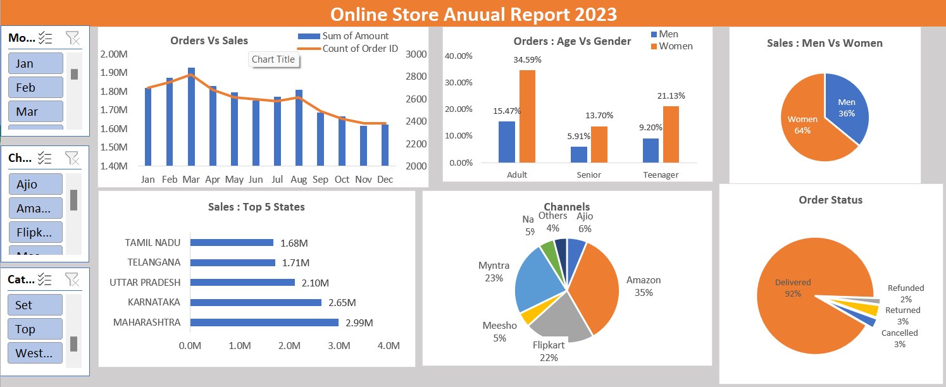

**Insights** :

* Women are more likely to buy compared to men (65%)
* Maharashtra, Karnataka and Uttar Pradesh are top 3 states (35%)
* Adult age group (30 to 49 years) are max contributing (50%)
* Amazon, Myntra and Flipkart channels are max contributing (80%)

**Conclusion** :

Target **women** customers of age group (**30 to 49** years) living in **Maharashtra, Karnataka and Uttar Pradesh** by showing adds/offers/coupons available on **Amazon, Flipkart and Myntra**.